Interactive Notebook One- Pager
Pre-AP

- Use the frame of the paper to write four specific facts you learned during the unit in complete sentences. (20 pts)

- Neatly write the title of the unit in the middle of the paper and spell it correctly. (10 pts) (ex. Geography, Citizenship, Exploration,…)

- In the middle of the paper, draw and color three pictures that go with the unit and label them. No naked stick people. (15 pts)

- Create a word cluster of at least 5 vocabulary terms from the unit somewhere in the middle of the paper. (5 pts)

- Create an acrostic poem about a historical person or vocabulary word
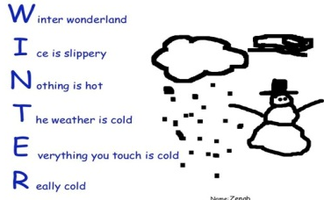
about the unit (MUST be at least four letters). Be sure that the
first letter for each line is BIG and BOLD. (10 pts)

- Write a “What if…?” question that asks how events in history might have changed if things were different. Be sure to properly punctuate your question. (10 pts)

- Complete a personal statement about what you read or studied in this unit starting with: “I believe...” Be sure your statement explains your thoughts about a topic in our unit. (10 pts)

- Make sure that your entire page is neat and legible. Everything must be colored and use something colorful (pen/marker) to outline all words or drawings that were originally done in pencil. (Be careful not to color so dark that you can no longer see what’s underneath.) (10 pts)

- All the space on the paper is used. There are no large empty white spaces. (10 pts)

